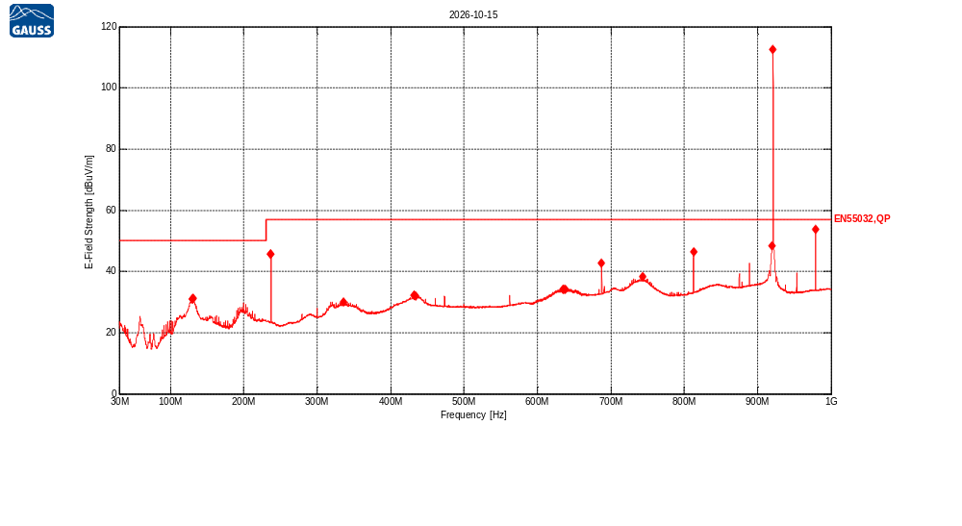
Receiver Model:
Protocol Number:
Serial Number:
Operation State:
Notes:
123123

Traces:
Trace | Start | Step | Stop | IF Bandwidth | Detector | Dwell time | Attenuation | Transducer | LISN | Notes
Scan2 | 30.0 MHz | 50.0 kHz | 1.0 GHz | 120kHz | QP | 200.0 ms | Auto | TDF1, TDF2, TDF3 | -

Transducers:
TDF1: Kabel Biru
TDF2: Heliax_Cable
TDF3: AaroniaHyperLog20600V (30M - 6GHz)

Limit lines:
EN55032,QP: EN55032 Rad 3m,Class A,OATS/SAC,QP, 30MHz-1000MHz
Scan2: 30.0 MHz, 50.0 kHz, 1.0 GHz; IF:120kHz, 200.0 ms QP, Att AutodB
f | Mag [dBuV/m] | Limit | Diff | Polarization | Height [cm] | Angle [°] | Trans | Name | Comment
129.995193 MHz | 31.09 | 50.00 | 18.91 | V | 100 | 0 | 22.56 | EN55032,QP
130.14167 MHz | 31.06 | 50.00 | 18.94 | V | 100 | 0 | 22.55 | EN55032,QP
130.874057 MHz | 31.13 | 50.00 | 18.87 | V | 100 | 0 | 22.45 | EN55032,QP
236.728344 MHz | 45.55 | 57.00 | 11.45 | V | 100 | 0 | 14.68 | EN55032,QP
236.874821 MHz | 45.58 | 57.00 | 11.42 | V | 100 | 0 | 14.67 | EN55032,QP
335.551718 MHz | 30.05 | 57.00 | 26.95 | V | 100 | 0 | 15.90 | EN55032,QP
431.738501 MHz | 32.11 | 57.00 | 24.89 | V | 100 | 0 | 18.52 | EN55032,QP
431.836152 MHz | 32.15 | 57.00 | 24.85 | V | 100 | 0 | 18.53 | EN55032,QP
434.228615 MHz | 32.08 | 57.00 | 24.92 | V | 100 | 0 | 18.66 | EN55032,QP
635.000214 MHz | 34.22 | 57.00 | 22.78 | V | 100 | 0 | 22.47 | EN55032,QP
636.172033 MHz | 34.19 | 57.00 | 22.81 | V | 100 | 0 | 22.50 | EN55032,QP
638.076238 MHz | 34.28 | 57.00 | 22.72 | V | 100 | 0 | 22.55 | EN55032,QP
687.536751 MHz | 42.69 | 57.00 | 14.31 | V | 100 | 0 | 22.02 | EN55032,QP
743.393441 MHz | 38.31 | 57.00 | 18.69 | V | 100 | 0 | 23.14 | EN55032,QP
812.579568 MHz | 46.48 | 57.00 | 10.52 | V | 100 | 0 | 24.00 | EN55032,QP
919.99628 MHz | 48.30 | 57.00 | 8.70 | V | 100 | 0 | 24.19 | EN55032,QP
920.972795 MHz | 112.47 | 57.00 | -55.47 | V | 100 | 0 | 24.15 | EN55032,QP | Failed
978.880168 MHz | 53.72 | 57.00 | 3.28 | V | 100 | 0 | 23.19 | EN55032,QP

